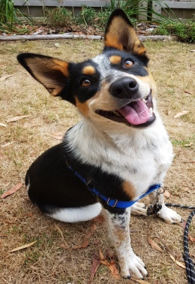
Dogs’ Homes of Tasmania Calendar Photo Competition
2021

- Only photos of Dogs and Puppies adopted from the Dogs’ Homes of Tasmania, and still with us, are eligible. Regardless of the year your dog was adopted.

- The winning photo entry will be on the calendar cover and artist David Bishop will paint a watercolour pawtraiture of the dog in the photo.

- We welcome a short written account of your dog with his/her photo.

- We regret we are not able to guarantee your dog’s photo will appear in the calendar and no correspondence will be entered into.

- There is no entry fee however donations are much appreciated.

- Entries must be received by 5 pm Friday 12th June 2020

- We require the following information with your Dog’s photo:

Your Name: ………………………………………… Phone: ………….…………………........
Address: Postal .…………………………………………………………………………………… Email ……………………………………………………………………………………...
Your Dog’s Name: ………………………………………………………………………….……
Which Dogs’ Home was your dog Adopted from …………………..………….      
Electronic Photos to : cbarryz@bigpond.net.au
Printed Photos to : Dogs’ Homes Calendar Committee PO Box 377 Moonah TAS 7009
- If you would like your photos returned, please include a SAE with your photo

- Are you happy for your photo and/or stories to be used in other
Dogs’ Homes publications? Please tick box for approval

